[Address by a graduate of the International Refugee Assistance Center: Mr. Tin Win, Chair of FWUBC]

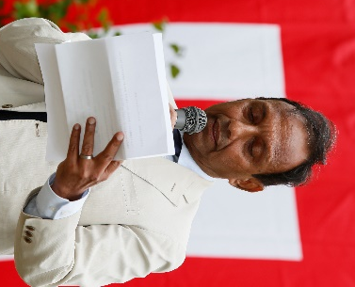
Hello, everyone. I am Tin Win.
It is an honor for me to give a speech at such a wonderful ceremony.
I fled to Japan on November 17, 1996, and was recognized as a refugee in February 1997.
I invited my wife and three children from Burma to join me in Japan in July 1997 and was able to reunite with them three years later.
When my children started studying in school here, they faced great difficulties with not only communicating in Japanese language but also with Japanese culture and daily habits, etc. They were clueless. Around that time, I heard about the International Refugee Assistance Center. Although I really wanted to join, the Center was unable to accept my family because it had no history of accepting convention refugees like me at the time.
However, I didn't give up and after much discussions, the Center accepted my family as an exception. Being an exceptional case, we couldn't receive the same treatment as refugees from Indochina and experienced many problems. Thanks to staff members who spent significant efforts on tackling these problems for my family, we were able to overcome these difficulties, and successfully graduated from the Center.

Learning at the Center was excellent, and enabled my children to understand Japanese language, culture, daily habits, and school subjects.
Thanks to that, all of my children studied and graduated from universities in Japan: my first daughter from Asia University, my first son from Kansai Gakuin University, and my second daughter from Aoyama Gakuin University. I am thankful for the Center.
While I faced many difficulties in my early days in the Center, the acceptance of my family as the first exceptional case led to the creation of opportunities for many convention refugees to receive its support. There are many convention refugees who learned at the Center and became able to adapt to the Japanese society.
The annual "Tsudoi" festival for refugees in Japan, in which dances and other cultural events from the home countries of the refugees were performed, was beneficial for improving mutual understanding among refugees from different countries.

I greatly appreciate what the Center has done for many refugees, including inviting people who have been displaced due to the conflict in Burma.

