[Address by a graduate of the International Refugee Assistance Center: Mr. Risei Kusunoki, President of CCJ]

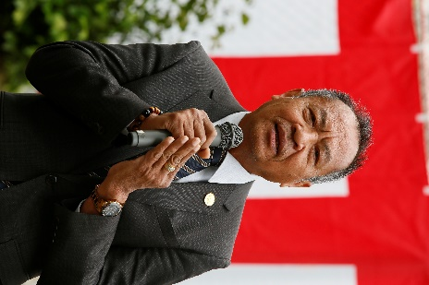
It's my great pleasure to give an address in front of all of you here. Thirty-seven years ago, I fled from Cambodia to a refugee camp in Thailand. Thirty-two years ago, I learned Japanese language and other topics in the International Refugee Assistance Center in Shinagawa. Although it doesn't exist anymore, the Center is a second home to me. I have many memories about the Center and really miss it. After leaving the Center, I moved to Chiba but I often took my family to this park to play.

I was forced to flee from Cambodia because of the national government's policy. It was really hard for me. News about displaced Ukrainians and Myanmarese reminds me of the pain I felt then. The refugee camp in Thailand where I reached after fleeing from Cambodia was simply a vast open field with nothing on it. I was filled with worries. There was not much food to go around, and sometimes I could only eat one meal of rice and canned food a day.

After I came to Japan and moved to the Center, I could get three meals a day and even refill my rice bowl. The Center served rice, bread, and many nutritious dishes. The other refugees and I were incredibly happy to have such good meals. The support of Japanese citizens, Shinagawa citizens, FWEAP and Refugee Assistance Headquarters staff allowed me to live without worries.

With the aim of returning such kindness as much as possible, I formed the Cambodia Community in Japan to perform volunteer activities. I would like to continue to contribute to the Japanese society. Thank you very much for giving me the opportunity to speak today.

