[Address by the President of FWEAP, Masahiro Fujiwara]

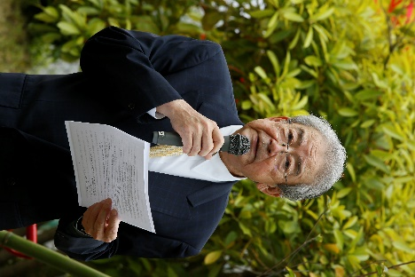
I sincerely congratulate all stakeholders for carrying out this ceremony under the initiative of refugees who have resettled in Japan. Now that the rain has stopped, we can celebrate the event with many participants. Together with the host, as a cooperation organization, FWEAP would like to thank Shinagawa City for its great support and cooperation.

The International Refugee Assistance Center operated near this Yashio Park from 1983 to 2006. During those 23 years of operation, the Center accepted more than 6,000 refugees from Vietnam, Laos, Cambodia, Myanmar, and other countries to help them resettle in Japan. This commemorative tree-planting is carried out by representatives of refugees who graduated from the Center.

The planning of this event was started two years ago mainly by the Association of Vietnamese in Japan. More than 45 years have passed since the first arrival of refugees from Indochina and now approximately 12,000 refugees and their families are living in Japan. The first generation of refugees are getting old, and their memories of the hardships they faced are fading away. For that reason, the people who proposed this project felt the necessity to reconfirm their gratitude towards the Japanese government and citizens, who warmly welcomed them, as well as to prompt younger generations to understand the importance of peace and freedom. These wishes motivated them to organize this commemorative tree-planting.
FWEAP agreed to support the project because we believe that this plan is beneficial for deepening mutual understanding between refugees who have resettled in Japan and Japanese citizens and for realizing the goal of FWEAP, that is, to establish an inclusive, multi-cultural society. The project has gained support from many refugee communities, including the seven communities of refugees from Vietnam, Laos, Cambodia, and Myanmar from which representatives are participating today.

Now, many refugees, including those from places other than Indochina, displaced people, and their families are resettled in Japan and have formed their communities. In the past, these refugee communities are considered to be under Japan's protection and support. In recent years, however, they are participating in the Japanese society through active social contributions, for example, by conducting volunteer activities in areas affected by earthquakes or typhoons and providing support for foreign students and technical interns who are suffering difficulties due to the COVID-19 pandemic.

FWEAP supports these activities as well as exchanges among refugee communities. I believe that this commemorative tree-planting is significant in that it was planned by refugee communities themselves and carried out based on cooperation among refugee communities from different home countries. I sincerely hope this commemorative tree-planting will further deepen the mutual understanding and communication between refugee communities and the Japanese society as well as among refugee communities.
Lastly, I would like to wish all those present here good health and success. That's the end of my congratulatory address. Thank you very much for your attention.

